**AND Digital**

**Deep Learning**

**Course Material for Week 4**

**Author: Rubaiyat Sadi**

Table of Contents

Computer Vision 1

Introduction 1

Deep Learning for Computer Vision: 1

Advantages of Deep Learning: 1

Convolutional Neural Networks (CNNs): 1

Transfer Learning: 1

Recent Advances and Trends: 2

Convolutional Neural Networks 3

Key Components of CNNs: 3

1. Convolutional Layers: 3

2. Pooling Layers: 4

4. Fully Connected Layers: 4

CNN Architectures: 5

LeNet-5: 5

AlexNet: 5

VGGNet: 6

ResNet: 6

Training and Optimization: 7

Preprocessing and data augmentation 9

Preprocessing: 9

Data Augmentation: 10

Object Detection and Localization 10

Region-based Methods: 11

Single-shot Methods: 11

Evaluation Metrics for Object Detection: 12

Semantic Segmentation 12

Fully Convolutional Networks (FCNs) for Pixel-level Classification: 13

Encoder-Decoder Architectures (e.g., U-Net): 13

Evaluation Metrics for Semantic Segmentation: 13

Instance Segmentation and Panoptic Segmentation: 14

Instance Segmentation and Its Challenges: 14

Mask R-CNN for Instance Segmentation: 14

Panoptic Segmentation and Its Integration of Instance and Semantic Segmentation: 15

Integration of Instance and Semantic Segmentation: 15

Image Generation and Style Transfer: 15

Generative Adversarial Networks (GANs) for Image Generation: 16

Conditional GANs for Controlled Image Synthesis: 16

Neural Style Transfer and Artistic Image Generation: 16

Transfer Learning and Model Interpretability: 17

Transfer Learning for Computer Vision Tasks: 17

Fine-tuning Pre-trained Models: 18

Interpreting Deep Learning Models: 18

Advanced Topics in Deep Computer Vision: 18

# Computer Vision

# Introduction

Computer vision refers to the field of study that focuses on enabling computers to understand and interpret visual information from images or videos. It involves tasks such as image recognition, object detection, image segmentation, and scene understanding.

Computer vision has widespread applications in various domains, including autonomous vehicles, surveillance systems, medical imaging, robotics, augmented reality, and image/video search.

Computer vision faces several challenges, such as variability in lighting conditions, occlusions, scale variations, viewpoint changes, and complex scene understanding.

## Deep Learning for Computer Vision:

### Advantages of Deep Learning:

Deep learning has significantly advanced computer vision tasks by automatically learning feature representations from raw pixel data, eliminating the need for handcrafted features. It excels in capturing intricate patterns and hierarchies present in images, leading to improved accuracy and performance.

### Convolutional Neural Networks (CNNs):

CNNs are specialized neural network architectures designed for computer vision tasks. They employ convolutional layers to scan input images with learnable filters, enabling local feature extraction and translation invariance. CNNs also use pooling layers to downsample feature maps and reduce spatial dimensions.

### Transfer Learning:

Transfer learning is a technique in deep learning where pre-trained models trained on large-scale datasets are utilized as a starting point for a specific task. By leveraging pre-trained models' learned representations, transfer learning accelerates training and improves performance, particularly in scenarios with limited labeled data.

Deep Learning Frameworks and Libraries:

Various deep learning frameworks and libraries (e.g., TensorFlow, PyTorch, Keras) provide high-level abstractions and tools for building, training, and deploying deep learning models for computer vision tasks. They offer pre-implemented CNN architectures, optimization algorithms, and convenient APIs for data processing.

### Recent Advances and Trends:

#### One-Shot Learning:

One-shot learning aims to recognize objects or classes with only a single example, addressing the challenges of limited labeled data.

Generative Models: Generative models, such as Variational Autoencoders (VAEs) and

#### Generative Adversarial Networks

(GANs), can generate new images, enhance image quality, and perform tasks like image inpainting and style transfer.

#### Attention Mechanisms:

Attention mechanisms enable models to focus on relevant image regions while performing tasks like object detection, image captioning, and visual question answering.

#### Explainability and Interpretability:

Understanding and interpreting deep learning models is crucial for trust, accountability, and debugging. Techniques like Grad-CAM and saliency maps provide insights into the important regions of an image for model predictions.

# Convolutional Neural Networks

CNNs are a specialized type of neural network architecture designed specifically for computer vision tasks. They have proven to be highly effective in analyzing visual data such as images and videos, surpassing traditional methods by automatically learning hierarchical representations from raw pixel data. CNNs excel at capturing local patterns and spatial relationships in images, making them well-suited for tasks like image classification, object detection, and image segmentation.

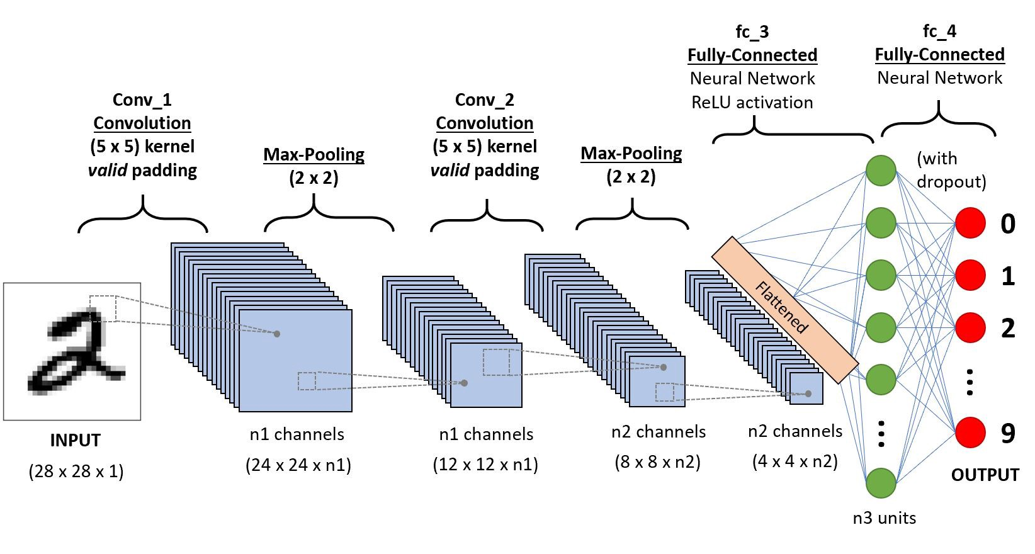

## Key Components of CNNs:

### 1. Convolutional Layers:

- Convolution Operation: Convolutional layers apply a set of learnable filters (also called kernels) to the input image. Each filter performs a dot product between its weights and a local patch of the input image, producing a feature map. Multiple filters capture different features such as edges, textures, or object parts.

- Feature Maps: Feature maps represent the activations of filters across the spatial dimensions of the input image. They highlight regions of the input that are important for recognizing specific features.

### 2. Pooling Layers:

- Downsampling and Dimensionality Reduction: Pooling layers reduce the spatial dimensions of the feature maps, effectively downsampling the information. The most commonly used pooling operation is max pooling, which selects the maximum value within a local region. This helps to abstract and retain the most salient features while reducing computational complexity.

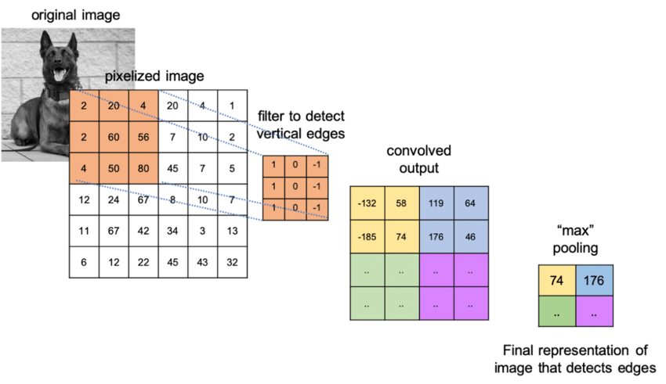

3. Activation Functions:

- Non-Linear Transformations: Activation functions introduce non-linearities into the CNN, allowing it to model complex relationships between inputs and outputs. Common activation functions used in CNNs include Rectified Linear Unit (ReLU), sigmoid, and hyperbolic tangent (tanh).

### 4. Fully Connected Layers:

- Classification and Decision Making: Fully connected layers are typically present towards the end of the CNN architecture. They connect every neuron from the previous layer to every neuron in the current layer, enabling the network to learn high-level representations and make predictions. These layers are often followed by a softmax activation function to produce class probabilities in classification tasks.

## CNN Architectures:

### LeNet-5:

Introduced by Yann LeCun in the 1990s, LeNet-5 was one of the pioneering CNN architectures for digit recognition. It consists of alternating convolutional and pooling layers, followed by fully connected layers.

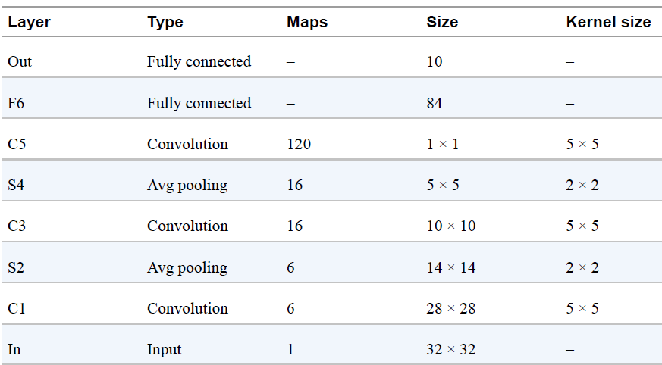

### AlexNet:

Proposed by Alex Krizhevsky et al. in 2012, AlexNet was a breakthrough architecture that achieved a significant performance boost in the ImageNet Large Scale Visual Recognition Challenge (ILSVRC). It has multiple convolutional layers, pooling layers, and fully connected layers, utilizing ReLU activation functions.

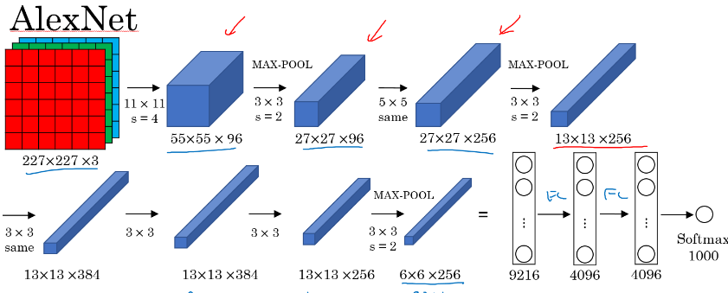

### VGGNet:

VGGNet, developed by the Visual Geometry Group at the University of Oxford, features a deeper architecture with a stack of smaller-sized convolutional layers. It gained popularity for its simplicity and achieved strong performance on various image recognition tasks.

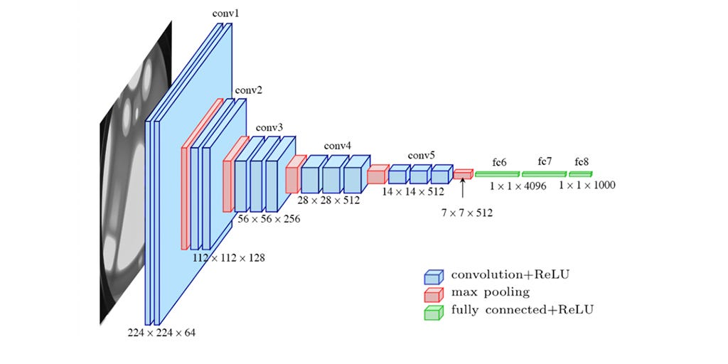

### ResNet:

Residual Networks, introduced by Kaiming He et al. in 2015, addressed the problem of vanishing gradients in very deep networks. ResNet introduced skip connections that allow information to flow directly across layers, enabling the training of extremely deep networks with improved performance.

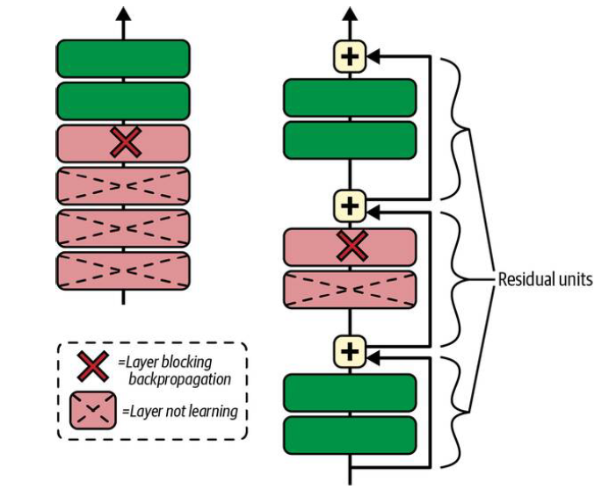

## Training and Optimization:

#### Backpropagation:

CNNs are trained using backpropagation, a gradient-based optimization technique. It calculates the gradients of the network's parameters with respect to a loss function and uses these gradients to update the parameters iteratively.

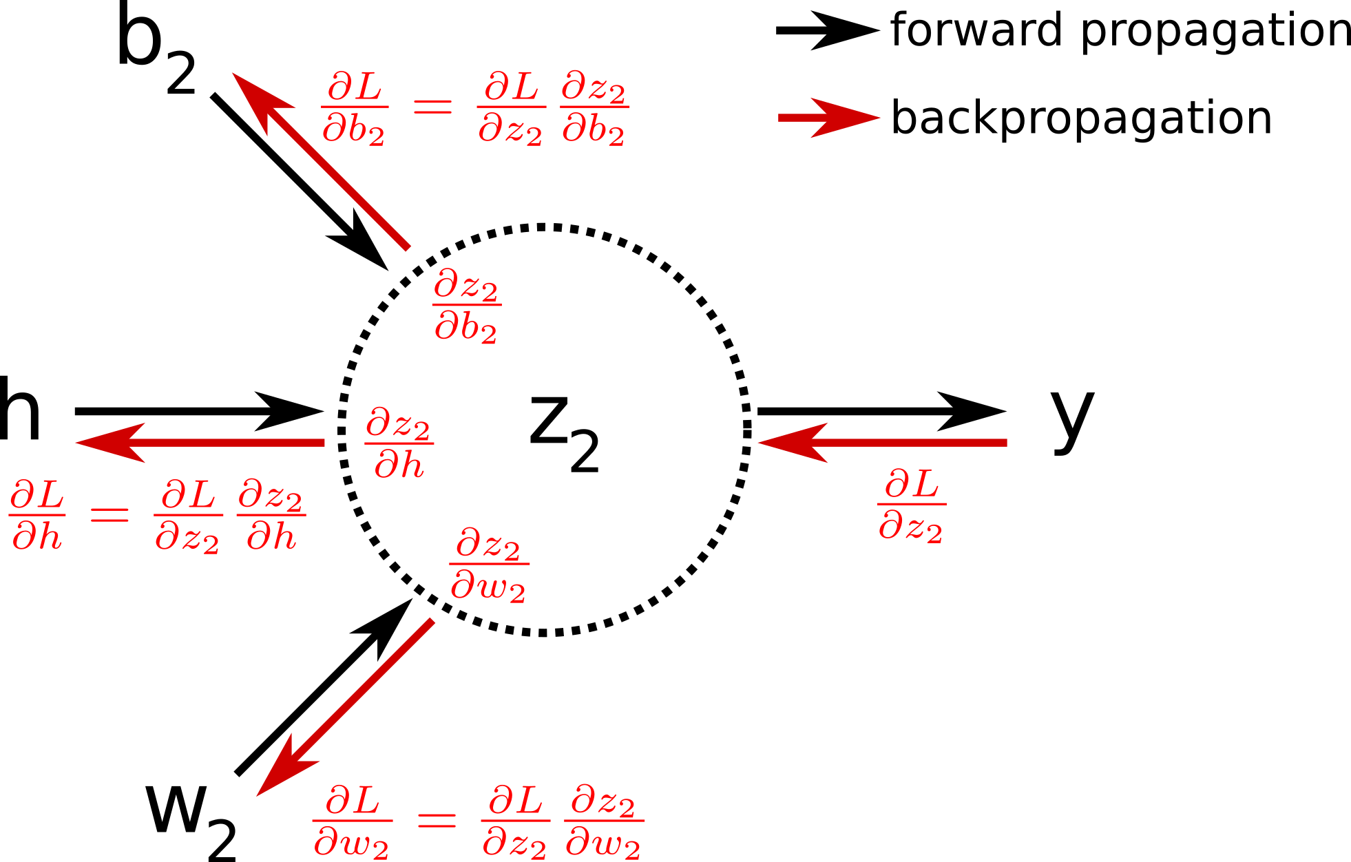

#### Loss Functions:

Common loss functions used in CNN training include categorical cross-entropy for multi-class classification and mean squared error for regression tasks. These loss functions quantify the difference between predicted and actual outputs, providing a measure of how well the network is performing.

#### Optimization Algorithms:

Stochastic Gradient Descent (SGD) and its variants, such as Adam and RMSprop, are widely used optimization algorithms for training CNNs. They update the network parameters based on the gradients calculated during backpropagation, aiming to find the optimal set of weights that minimize the loss function.

#### Regularization Techniques:

Regularization techniques like L1 and L2 regularization, dropout, and batch normalization are often applied to prevent overfitting and improve the generalization ability of CNNs. Regularization helps the network avoid memorizing training examples and promotes better feature learning.

CNNs have become a cornerstone of modern computer vision systems, driving advancements in image recognition, object detection, image segmentation, and many other visual tasks. Their ability to automatically learn hierarchical representations from raw pixel data, coupled with their specialized architectural design, makes them a powerful tool for analyzing and understanding visual information.

# Preprocessing and data augmentation

are crucial steps in preparing data for training deep learning models, including Convolutional Neural Networks (CNNs) used in computer vision tasks. These techniques help to improve model performance, increase generalization capabilities, and handle challenges such as limited data and variations in images.

## Preprocessing:

Preprocessing involves transforming raw input data into a suitable format for CNN training. It typically includes the following steps:

1. Data Normalization: Normalizing the data ensures that the input features have similar scales, preventing certain features from dominating the learning process. Common normalization techniques include scaling pixel values to a range of [0, 1] or standardizing them to have zero mean and unit variance.

2. Resizing and Cropping: Images in a dataset may have varying sizes, so resizing them to a consistent size is often necessary. This ensures that all images have the same input dimensions for CNN processing. Additionally, cropping images can help focus on specific regions of interest, removing irrelevant background information.

3. Data Cleaning: Data cleaning involves removing or correcting any data inconsistencies, such as corrupted images or mislabeled samples. It ensures the dataset is of high quality and reduces the potential for noisy or erroneous data to impact model performance.

4. Handling Imbalanced Datasets: In some cases, the dataset may be imbalanced, meaning certain classes have significantly fewer samples than others. Techniques like oversampling the minority class, undersampling the majority class, or using class weights during training can help address class imbalance issues.

## Data Augmentation:

Data augmentation is a technique used to artificially increase the diversity and size of the training dataset by applying various transformations to the existing data. It helps to improve model generalization and robustness by exposing the network to a wider range of variations. Common data augmentation techniques include:

1. Flipping and Rotation: Mirroring or flipping images horizontally or vertically can create new training samples that preserve class labels. Rotation by a certain degree can also help the model generalize to objects in different orientations.

2. Translation and Scaling: Shifting an image horizontally or vertically and applying scaling transforms can simulate variations in object position and size. This enables the model to learn to recognize objects regardless of their location within the image.

3. Brightness and Contrast Adjustment: Altering the brightness and contrast levels of images can introduce variations in lighting conditions, making the model more robust to different illumination settings.

4. Noise Injection: Adding random noise to images can simulate real-world imperfections and variations, making the model more tolerant to noisy or low-quality images.

5. Elastic Deformation: Applying elastic deformations to images by distorting them locally can help the model learn to recognize objects under different deformations or perspectives.

It's important to note that data augmentation should be applied during training only, not during validation or testing, as it artificially modifies the data. Additionally, the choice and extent of data augmentation techniques depend on the specific problem domain and the characteristics of the dataset.

Overall, preprocessing and data augmentation play vital roles in preparing and enhancing the training data for CNNs. These techniques aid in reducing overfitting, improving generalization, and enabling CNNs to learn robust and discriminative features from the available data.

# Object Detection and Localization

Object detection and localization refer to the tasks of identifying and localizing objects of interest within an image or a video frame. These tasks are fundamental in computer vision and have numerous applications, such as autonomous driving, surveillance systems, and image understanding. Unlike image classification, object detection involves not only recognizing the presence of objects but also determining their spatial extent within the image.

## Region-based Methods:

Region-based methods have been widely used for object detection and localization. They operate by first generating a set of candidate regions that are likely to contain objects and then classifying and refining these regions to obtain accurate detections. Several notable region-based methods include R-CNN (Region-based Convolutional Neural Networks), Fast R-CNN, and Faster R-CNN.

R-CNN: R-CNN was one of the pioneering region-based methods. It generates region proposals using selective search or a similar method and then applies a CNN to each proposed region to extract features. These features are subsequently fed into a set of linear SVMs (Support Vector Machines) for object classification.

Fast R-CNN: Fast R-CNN improved upon R-CNN by sharing the convolutional features across different region proposals. Instead of applying a CNN to each region proposal separately, Fast R-CNN extracts features for the entire image and uses a region of interest (ROI) pooling layer to extract features for each region. This significantly speeds up the computation.

Faster R-CNN: Faster R-CNN introduced a region proposal network (RPN) that shares convolutional features with the object detection network. The RPN generates region proposals directly from the shared features, eliminating the need for an external region proposal method. The shared features are then used for object classification and bounding box regression.

## Single-shot Methods:

Single-shot methods offer an alternative approach to object detection that aims to achieve real-time performance without relying on region proposal methods. These methods directly predict object bounding boxes and class probabilities from predefined anchor boxes across different spatial locations and scales in the image. Two popular single-shot methods are YOLO (You Only Look Once) and SSD (Single Shot MultiBox Detector).

YOLO: YOLO divides the input image into a grid and predicts bounding boxes and class probabilities directly from the grid cells. It uses a single CNN to make predictions for the entire image at once, resulting in fast inference. However, YOLO may struggle with small objects and accurately localizing objects with overlapping bounding boxes.

SSD: SSD is another single-shot method that operates at multiple feature scales. It uses a set of predefined anchor boxes of different aspect ratios at each scale to predict object bounding boxes and class probabilities. By incorporating features from multiple scales, SSD can effectively handle objects of various sizes and aspect ratios.

## Evaluation Metrics for Object Detection:

To assess the performance of object detection algorithms, various evaluation metrics are used. Some commonly used metrics include Average Precision (AP), Precision-Recall curves, and Intersection over Union (IoU).

Average Precision (AP): AP measures the precision of object detections at different recall levels. It calculates the area under the precision-recall curve, providing an overall measure of detection accuracy. AP is often reported at different IoU thresholds (e.g., 0.5, 0.75) to assess detection performance under different localization tolerances.

Precision-Recall (PR) curves: PR curves visualize the trade-off between precision and recall at different confidence thresholds. They are useful for comparing different object detection models and selecting appropriate operating points based on the desired precision and recall trade-offs.

Intersection over Union (IoU): IoU is a crucial measure for evaluating the accuracy of bounding box predictions. It quantifies the overlap between the predicted bounding box and the ground truth bounding box. IoU is computed as the ratio of

the intersection area between the two boxes to their union area. A high IoU indicates a more accurate localization.

These evaluation metrics help researchers and practitioners quantify and compare the performance of different object detection methods, aiding in the development and improvement of state-of-the-art techniques in object detection and localization.

# Semantic Segmentation

Semantic segmentation is a computer vision task that aims to assign a class label to each pixel in an image, thereby partitioning the image into different regions corresponding to different object categories or semantic classes. It provides fine-grained pixel-level understanding of an image and finds applications in various fields, such as autonomous driving, medical image analysis, and scene understanding.

## Fully Convolutional Networks (FCNs) for Pixel-level Classification:

Fully Convolutional Networks (FCNs) revolutionized semantic segmentation by extending the capabilities of convolutional neural networks (CNNs) to handle dense pixel predictions. Unlike traditional CNN architectures that output a single label for the entire image, FCNs allow predictions for each pixel in the image. FCNs achieve this by replacing fully connected layers with convolutional layers, enabling end-to-end pixel-level classification.

## Encoder-Decoder Architectures (e.g., U-Net):

Encoder-Decoder architectures, such as the U-Net, have become popular in semantic segmentation. These architectures consist of an encoder path that gradually reduces spatial resolution while capturing high-level features and a decoder path that recovers the spatial resolution while incorporating fine-grained details for accurate segmentation. The skip connections between corresponding encoder and decoder layers enable the fusion of multi-scale information, facilitating both global context understanding and precise localization.

## Evaluation Metrics for Semantic Segmentation:

Evaluating the performance of semantic segmentation algorithms requires appropriate metrics that assess the quality of the predicted segmentations. Common evaluation metrics include Intersection over Union (IoU), Pixel Accuracy, and Mean Intersection over Union (mIoU).

Intersection over Union (IoU): IoU measures the overlap between the predicted segmentation and the ground truth mask for a given class. It computes the ratio of the intersection area to the union area between the two regions. Higher IoU values indicate better segmentation accuracy.

Pixel Accuracy: Pixel Accuracy calculates the percentage of correctly classified pixels, regardless of the class. It provides a measure of overall segmentation accuracy but may not capture class-specific performance.

Mean Intersection over Union (mIoU): mIoU calculates the average IoU across all classes. It provides an aggregated measure of segmentation accuracy, taking into account the performance of each individual class. mIoU is widely used to compare and rank different semantic segmentation models.

## Instance Segmentation and Panoptic Segmentation:

Instance segmentation and panoptic segmentation are extensions of semantic segmentation that provide more detailed information about objects within an image.

Instance Segmentation: Instance segmentation involves not only assigning semantic labels to each pixel but also differentiating between individual instances of the same class. It provides a pixel-level distinction between different objects and is useful in scenarios where precise object boundaries and counting are required.

Panoptic Segmentation: Panoptic segmentation combines semantic segmentation and instance segmentation by unifying the predictions into a single coherent output. It assigns a unique label to each pixel, indicating the object category for semantic regions and instance IDs for individual object instances. Panoptic segmentation aims to provide a comprehensive understanding of the scene, encompassing both stuff (e.g., sky, road) and things (e.g., cars, pedestrians).

Semantic segmentation, along with its variants like instance segmentation and panoptic segmentation, plays a vital role in advanced computer vision applications, enabling fine-grained analysis and understanding of visual data at the pixel level. These techniques continue to advance and find application in a wide range of domains, contributing to the development of intelligent systems.

# Instance Segmentation and Its Challenges:

Instance segmentation is a computer vision task that involves not only assigning semantic labels to each pixel but also delineating individual object instances within an image. It provides pixel-level differentiation between objects of the same class, enabling precise object localization and understanding. Instance segmentation poses unique challenges compared to semantic segmentation, including occlusion, overlapping instances, and varying object scales. Handling these challenges requires algorithms that can accurately delineate object boundaries and distinguish between closely packed objects.

## Mask R-CNN for Instance Segmentation:

Mask R-CNN is a state-of-the-art framework for instance segmentation that builds upon the region-based approach of Faster R-CNN. It extends Faster R-CNN by adding a branch for predicting segmentation masks alongside the existing branches for object classification and bounding box regression. Mask R-CNN combines the advantages of both object detection and semantic segmentation by generating precise instance masks for individual objects in addition to class labels and bounding boxes. It achieves this by utilizing a parallel mask prediction branch that shares features with the object detection branch. Mask R-CNN has demonstrated outstanding performance in various instance segmentation challenges and has become a popular choice for this task.

## Panoptic Segmentation and Its Integration of Instance and Semantic Segmentation:

Panoptic segmentation aims to provide a unified understanding of visual scenes by integrating instance segmentation and semantic segmentation. It assigns unique labels to each pixel, distinguishing between individual instances and semantic regions. The goal is to provide a comprehensive representation that combines fine-grained object-level information with global context understanding. Panoptic segmentation has emerged as an important task to bridge the gap between instance and semantic segmentation, enabling a holistic understanding of scenes that encompasses both object-level details and scene-level context.

## Integration of Instance and Semantic Segmentation:

The integration of instance and semantic segmentation in panoptic segmentation involves combining the predictions from both tasks to produce a unified result. This integration can be achieved through various approaches, such as combining instance masks with semantic segmentation labels or merging instance-level and semantic-level features. The goal is to create a coherent representation that captures both the fine-grained object boundaries and the global context of the scene.

## Image Generation and Style Transfer:

Image generation and style transfer are areas of computer vision and deep learning that deal with creating new images or transforming existing images to exhibit specific styles or characteristics.

Image Generation: Image generation refers to the process of generating entirely new images from scratch using deep learning models, such as generative adversarial networks (GANs) or variational autoencoders (VAEs). These models learn from a dataset of images and can generate novel, realistic images that resemble the training data. Image generation has applications in various domains, including art, entertainment, and data augmentation for training deep learning models.

Style Transfer: Style transfer is a technique that aims to apply the style of one image to another, combining the content of one image with the artistic or visual style of another. This is typically achieved by using deep neural networks to separate and recombine the content and style representations of two input images. Style transfer techniques have gained popularity for creating artistic effects, transforming photographs into paintings, and generating visually appealing images.

Both image generation and style transfer utilize deep-learning models to manipulate and generate images. These techniques have opened up new possibilities in creative expression and image manipulation, enabling the generation of unique visuals and artistic effects.

# Generative Adversarial Networks (GANs) for Image Generation:

Generative Adversarial Networks (GANs) have revolutionized the field of image generation by pitting two neural networks against each other: a generator network and a discriminator network. The generator network learns to generate new images from random noise, while the discriminator network aims to distinguish between real and generated images. Through an adversarial training process, the generator progressively improves its ability to generate realistic images that can fool the discriminator. GANs have demonstrated remarkable success in generating high-quality images across various domains, including faces, scenes, and objects.

## Conditional GANs for Controlled Image Synthesis:

Conditional GANs (cGANs) extend the basic GAN framework by conditioning the generator on additional input information, such as class labels or auxiliary data. By providing explicit control over the image generation process, cGANs enable controlled synthesis of images that meet specific criteria or exhibit desired characteristics. For example, in the context of image-to-image translation, cGANs can be conditioned on an input image to generate a corresponding output image with desired modifications, such as changing the season of a landscape or converting a daytime image to a nighttime scene.

## Neural Style Transfer and Artistic Image Generation:

Neural style transfer is a technique that combines the content of one image with the artistic style of another, resulting in a new image that exhibits the content of the input image with the visual style of the reference image. It utilizes deep neural networks to separate and recombine the content and style representations of the input images. By capturing the underlying patterns and textures of the reference image and applying them to the content image, neural style transfer allows for the creation of visually appealing and artistic images. This technique has gained popularity in various applications, including image stylization, artistic image generation, and visual effects.

## Transfer Learning and Model Interpretability:

Transfer learning is a technique that leverages pre-trained deep learning models to tackle new tasks or domains with limited labeled data. By utilizing knowledge learned from large-scale datasets, pre-trained models can be fine-tuned or used as feature extractors for new tasks, enabling faster convergence and improved performance. Transfer learning has become an essential tool in deep learning, especially when dealing with limited data availability or complex tasks.

Model Interpretability refers to the ability to understand and interpret the decisions made by deep learning models. As deep learning models often operate as complex black boxes, interpreting their inner workings can be challenging. Various techniques have been developed to shed light on the decision-making process of deep learning models, such as visualization methods (e.g., saliency maps, activation maps) and feature attribution techniques (e.g., Grad-CAM, LIME). These techniques help uncover the important features and patterns considered by the model when making predictions, enhancing transparency and trust in deep learning models.

Transfer learning and model interpretability are crucial aspects of deep learning model development, enabling the application of pre-trained models to new tasks and providing insights into how models arrive at their predictions. These techniques facilitate knowledge transfer, model understanding, and practical deployment of deep learning models in real-world scenarios.

# Transfer Learning for Computer Vision Tasks:

Transfer learning is a powerful technique in the field of computer vision that enables the use of pre-trained models to tackle new tasks or domains with limited labeled data. By leveraging the knowledge learned from large-scale datasets, transfer learning helps address the challenge of data scarcity and facilitates faster convergence and improved performance for new tasks. In transfer learning, a pre-trained model, often trained on a large dataset like ImageNet, is utilized as a starting point. The weights of the pre-trained model are either frozen or fine-tuned, and additional layers are added or modified to adapt the model to the specific task at hand. This process allows the model to learn task-specific features while benefiting from the general knowledge captured by the pre-trained model.

## Fine-tuning Pre-trained Models:

Fine-tuning is a common approach in transfer learning where a pre-trained model's weights are further updated on a new target task. By adjusting the model's parameters using task-specific data, fine-tuning allows the model to adapt to the new task while retaining the knowledge gained from the pre-training stage. The process typically involves freezing some initial layers of the pre-trained model, which capture low-level features, and allowing the later layers to be updated during training. Fine-tuning enables the model to specialize in the new task by learning task-specific features, resulting in improved performance even with limited labeled data.

## Interpreting Deep Learning Models:

Interpreting deep learning models is essential for understanding their inner workings and building trust in their decisions. Deep learning models often operate as complex black boxes, making it challenging to comprehend how they arrive at their predictions. To address this, various interpretability techniques have been developed.

Feature Visualization: Feature visualization techniques aim to visualize and understand the learned features in a deep learning model. These techniques generate visual representations of features learned by specific layers or neurons, providing insights into the patterns and representations captured by the model during training. Examples of feature visualization techniques include activation maximization, which generates input stimuli that maximize the activation of a specific neuron, and filters visualization, which visualizes the learned convolutional filters.

Attribution Methods: Attribution methods help attribute the importance or contribution of input features to the model's predictions. These methods highlight the regions or pixels in the input image that have the most significant influence on the model's decision-making. Techniques like Grad-CAM (Gradient-weighted Class Activation Mapping) and LIME (Local Interpretable Model-agnostic Explanations) provide interpretability by producing heatmaps or masks that indicate the importance of different regions in the input image.

# Advanced Topics in Deep Computer Vision:

Advanced topics in deep computer vision encompass a wide range of cutting-edge research areas and techniques. These may include but are not limited to:

- Object detection and tracking: Techniques for detecting and tracking objects in images or videos, such as region-based methods (e.g., R-CNN, Faster R-CNN) and single-shot methods (e.g., YOLO, SSD).

- 3D computer vision: Methods for understanding and reconstructing three-dimensional scene information from two-dimensional images, including depth estimation, structure from motion, and 3D object recognition.

- Video understanding: Approaches to analyze and comprehend video data, including action recognition, video segmentation, and video captioning.

- Generative models: Techniques for generating new content, such as generative adversarial networks (GANs), variational autoencoders (VAEs), and their applications in image synthesis, style transfer, and data augmentation.

- Domain adaptation: Methods for adapting deep learning models from a source domain to a target domain with different distributions, enabling models trained on one dataset to perform well on another dataset.

- Weakly supervised learning: Approaches to train deep learning models using weak supervision, such as image-level labels or bounding box annotations,

instead of pixel-level annotations, reducing the need for extensive manual labeling efforts.

These advanced topics represent areas of ongoing research and development in deep computer vision, pushing the boundaries of what is possible and driving advancements in the field. They offer exciting opportunities for further exploration and innovation in computer vision applications.